


A Comprehensive Analytics Study Using Power BI, NLP, and Piracy Data

Group Number: 11
Course: MSBA 286 – Capstone Project II
Eberhardt School Of Business
University of the Pacific
Stockton, California
Professor: Xun (Peter) Xu Ph.D.
Semester: Fall 2025

Group Members
Madhukar Goli 989501269


TABLE OF CONTENTS
- Introduction
- Project Background & Motivation
- Data Sources & Preparation
- Methodology
  - 4.1 ETL Workflow
  - 4.2 NLP Keyword Extraction
  - 4.3 Power BI Modeling
  - 4.4 Relationship Modeling
- Dashboard & Visual Analytics
  - 5.1 Piracy Analytics
  - 5.2 Revenue Analytics
  - 5.3 Genre Insights
  - 5.4 NLP Keyword Drivers
  - 5.5 Story Length & Downloads
  - 5.6 Industry-Level Performance
- Results & Findings
- Managerial Interpretation

- Limitations
- Conclusion
- References
- Appendix: Dashboard Screenshots
1. INTRODUCTION
The global movie industry creates billions in revenue, yet continues to face rising challenges from online piracy, unpredictable audience preferences, and rapidly evolving content formats. As streaming platforms gain dominance, understanding what drives a film’s financial and audience performance is critical for studios, marketing teams, and distribution companies.
This project integrates:
- NLP analysis (movie storyline keywords)
- Piracy behavior & download patterns
- Financial indicators (budget, revenue, industry differences)
- User engagement & IMDb ratings
- Visual analytics using Power BI
Our final goal was to uncover what factors contribute most strongly to movie success, both in terms of legitimate revenue and piracy-driven demand.


2. PROJECT BACKGROUND & MOTIVATION
The film industry has limited visibility into:
- Why certain films are pirated heavily
- Which genres generate higher ROI
- Whether story complexity influences attention
- How ratings and downloads correlate
- How NLP-derived themes influence piracy

Traditional analytics focuses on revenue alone, but piracy consumption provides a hidden signal of global interest.

Understanding these hidden signals adds value for:
- Studios (Paramount, Disney, Universal)
- Streaming platforms (Netflix, Amazon Prime)
- Marketing teams
- Content publishers
This dataset allows us to explore patterns that are otherwise unobservable.


3. DATA SOURCES & PREPARATION

Primary datasets used:
- Movies Metadata (TMDb API + Kaggle dataset)
- Movies Dataset (Downloads + Industry Data)
- Keywords Dataset (Storyline-based NLP features)
- Ratings Dataset (IMDb ratings)
- Credits Dataset (Cast & Crew)

Data Cleaning Steps
- Removal of missing IDs and null movie titles
- Standardization of release dates
- Cleaning genre labels into Genre Category & Genre Family
- Creating numeric fields (budget, revenue, downloads, rating)
- Extracting storyline keywords using Power Query text transformations
- Creating a clean keywords column with Regex and delimiter cleanup


Data Cleaning Workflow Diagram
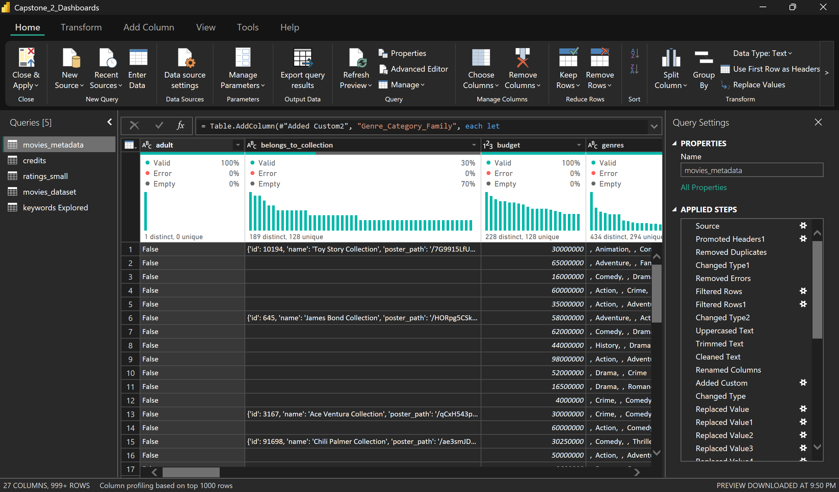

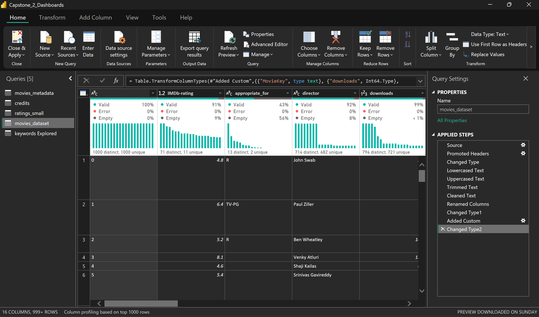

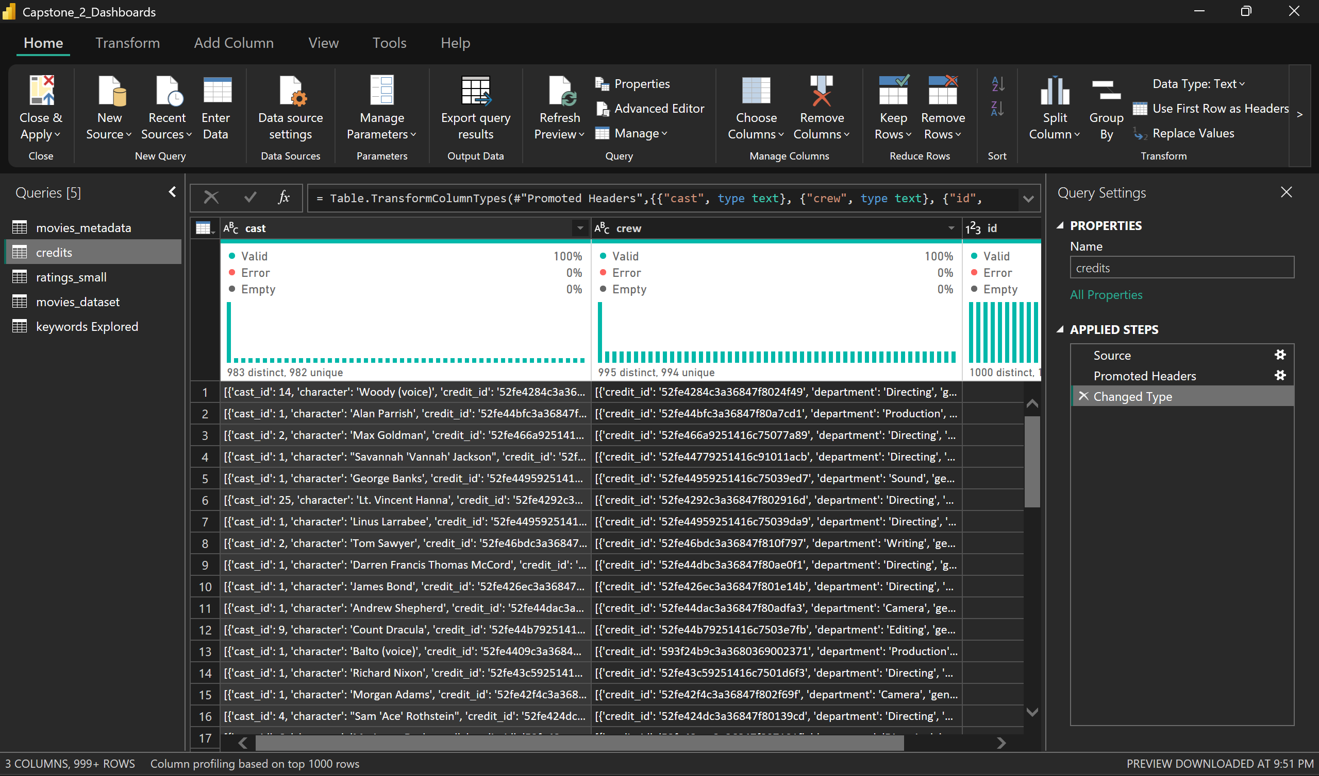

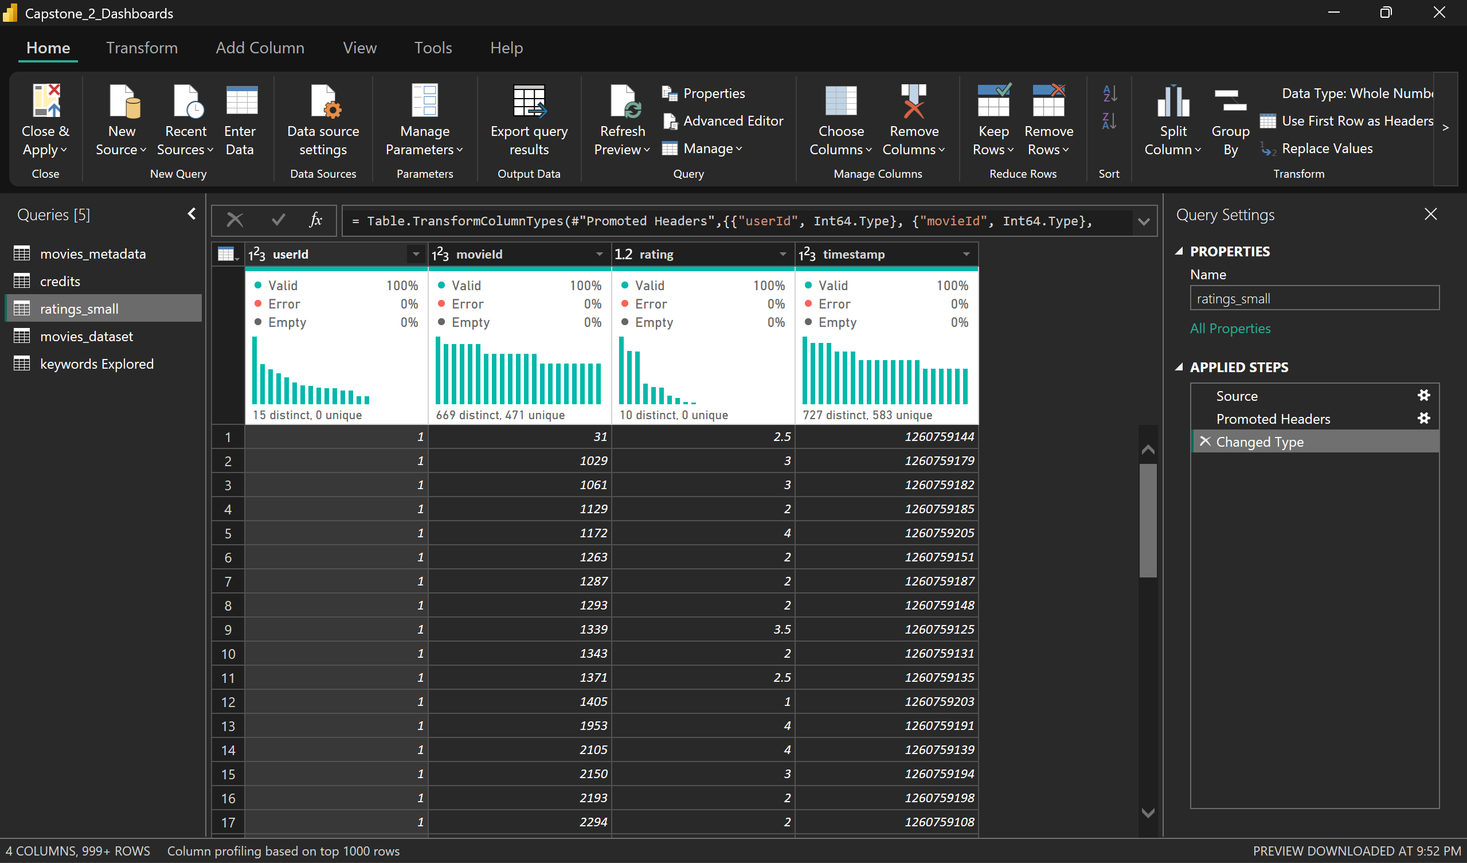

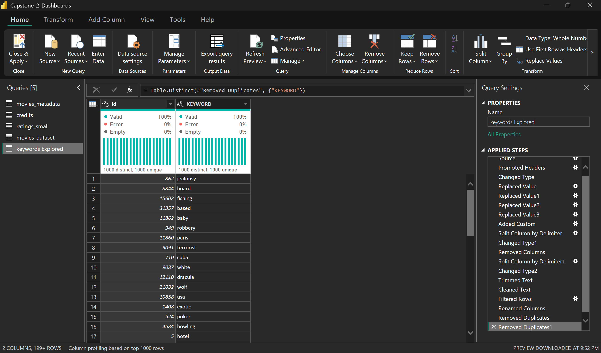

4. METHODOLOGY

4.1 ETL Workflow
- Data imported into Power BI
- Missing values handled
- Relationship model built using:
  - MovieID
  - MovieKey
  - KeywordID

- Created DAX measures for revenue, downloads, averages, and keyword-based aggregations

4.2 NLP Keyword Extraction

- Cleaned the keywords column using:

  - Text.BeforeDelimiter
  - Text.Select
  - Text.Trim

- Extracted top themes via grouping + ranking
4.3 Relationship Modeling
Final Model Features:
- Keywords[id] → Movies_Metadata[id] (Many-to-One)
- Movies_Metadata[MovieKey] → Movies_Dataset[MovieKey] (Many-to-Many)
- Ratings_small linked by movieId


POWER BI RELATIONSHIP MODEL
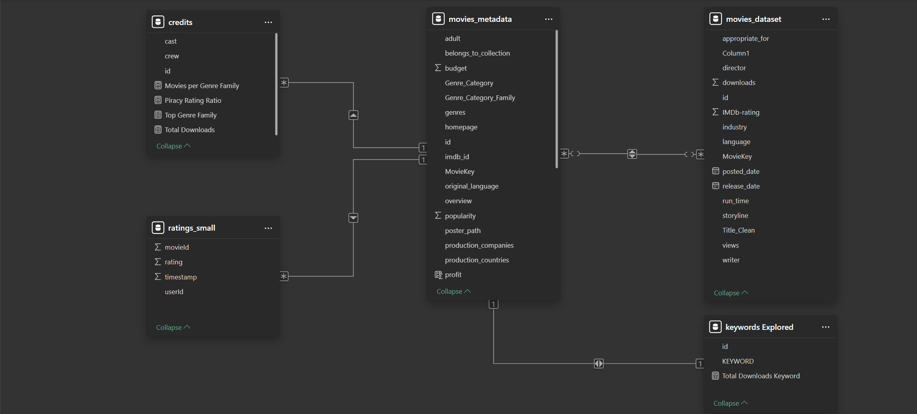
4.4 Measure Creation (DAX)
Examples:
- Total Downloads
- Top 20 Keywords Driving Piracy
- Average Budget by Genre
- Genre Family Insights
- Keyword-based Download Aggregation


5. DASHBOARD & VISUAL ANALYTICS
Below are placeholders for each dashboard, with the content describing insights.
5.1 Top 20 Most Pirated Movies
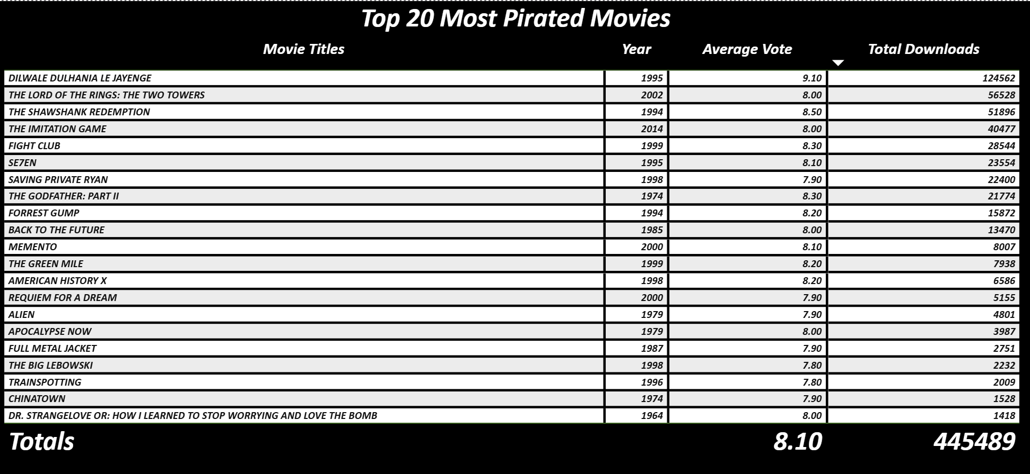
Key insights:
- Older classics rank surprisingly high due to cultural relevance
- Action & drama dominate piracy demand
- High ratings correlate with high piracy, implying quality drives downloads


5.2 Top 20 Keywords Driving Piracy (NLP)
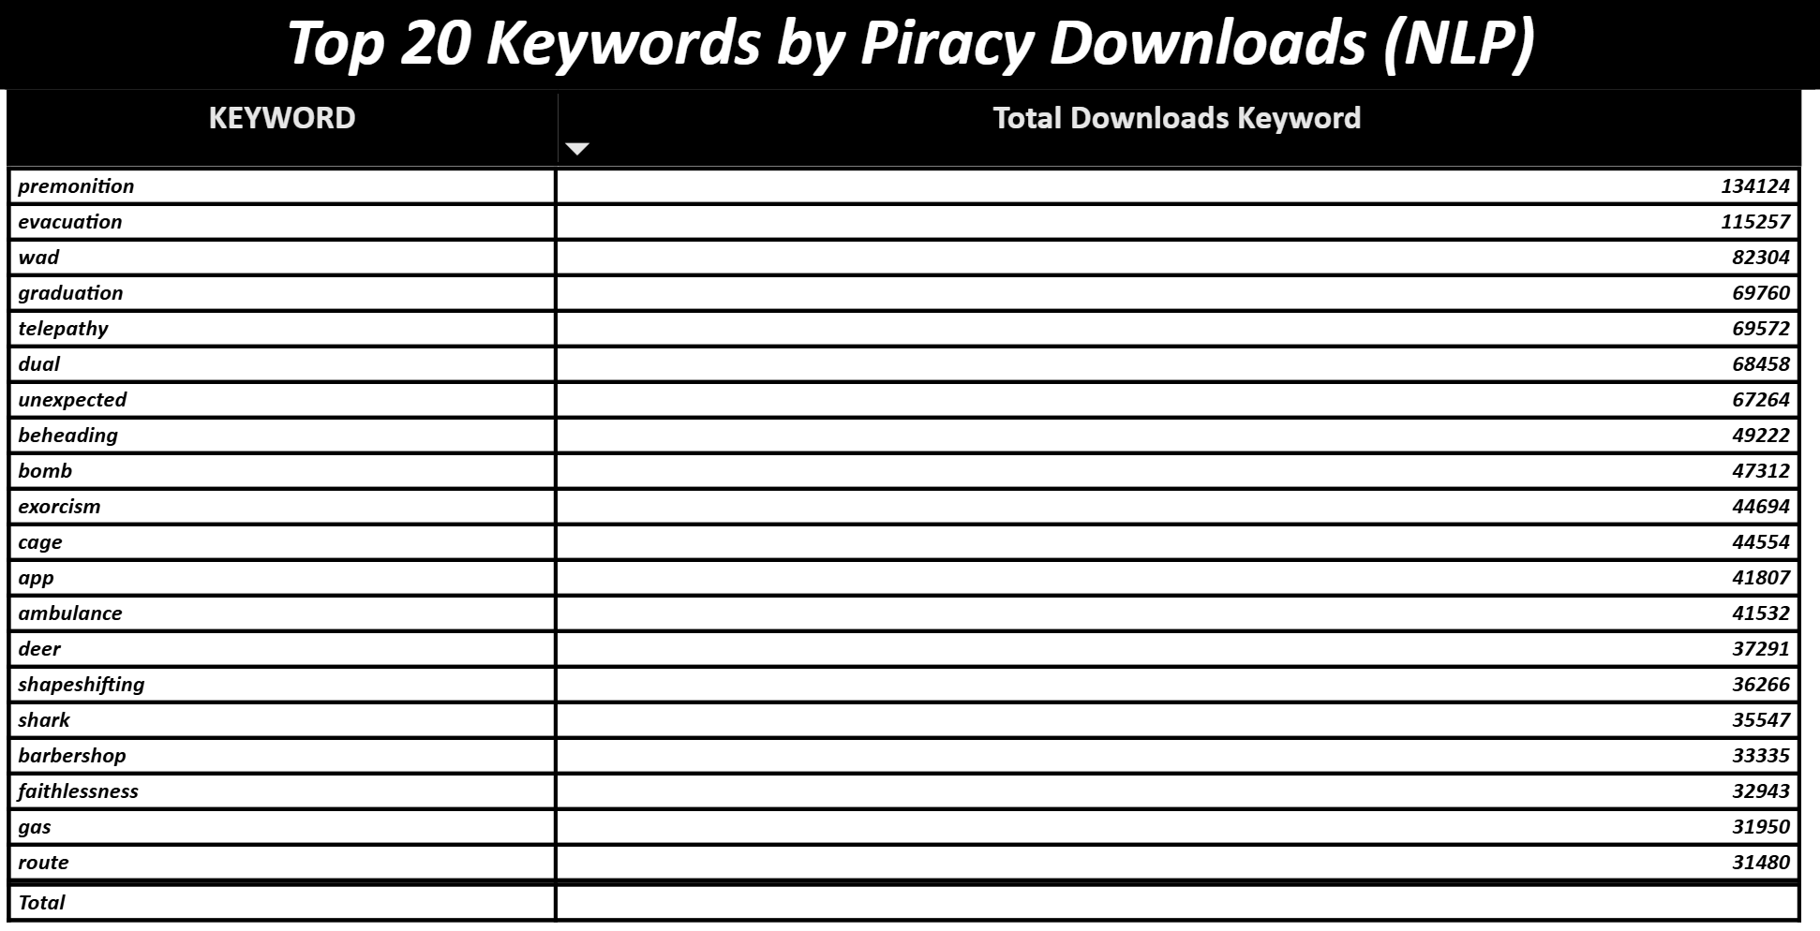
Main patterns:
- Action themes (“revengе”, “escape”, “fight”, “bomb”) dominate piracy
- Emotional themes (“betrayal”, “loss”) also contribute
- Story elements with broader appeal attract more illegal viewers


5.3 Genre Insights – Piracy Trend by Year
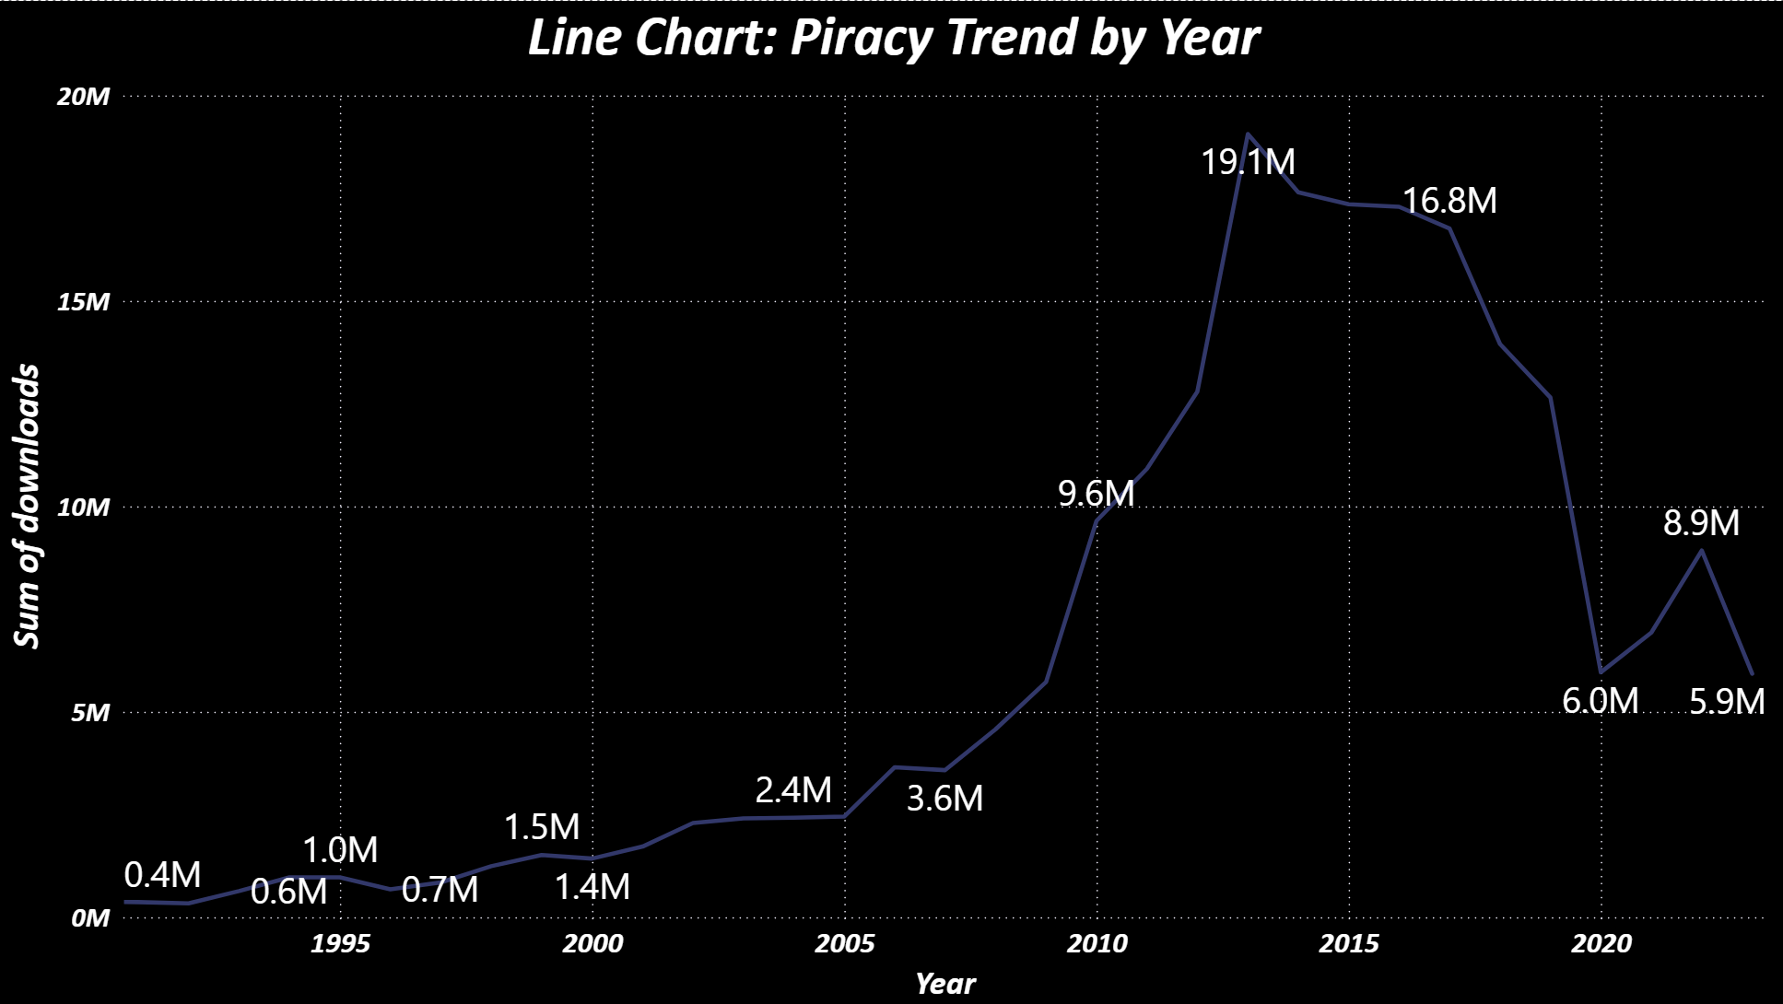
Observations:
- Major spike around 2013–2016
- Decline during streaming boom (2019–2020)
- Gradual rise again in 2022–2023


5.4 Average Budget by Genre
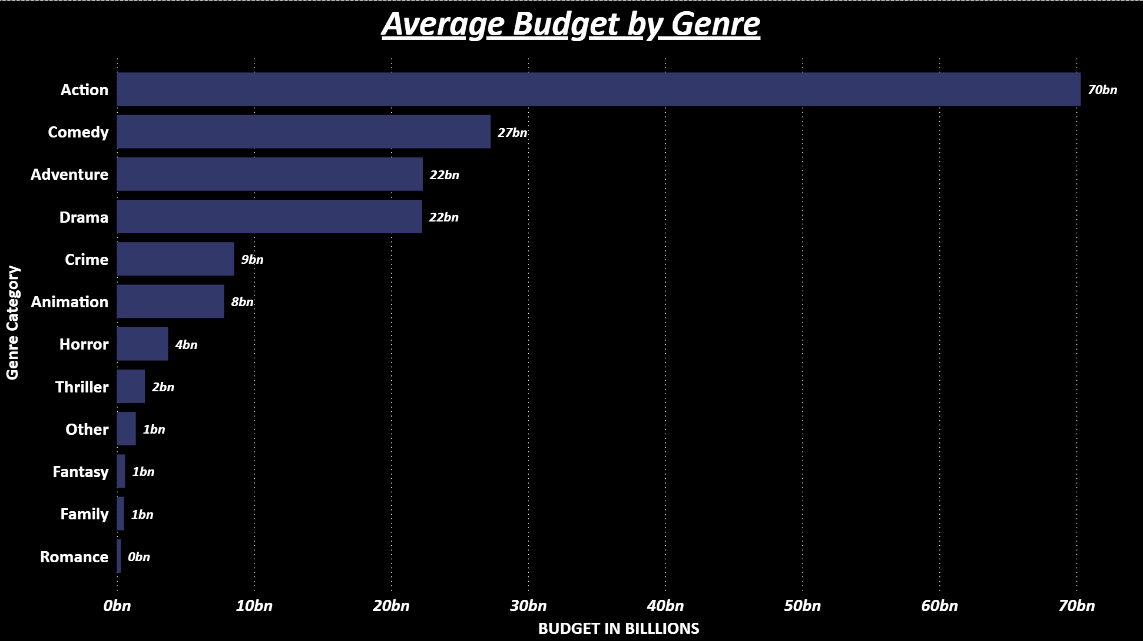

Key findings:
- Action films lead in budget (70B cumulative)
- Horror & Thriller maintain impact with low investment
- Animation surprisingly high cost


5.5 Industry-Level Budget Patterns
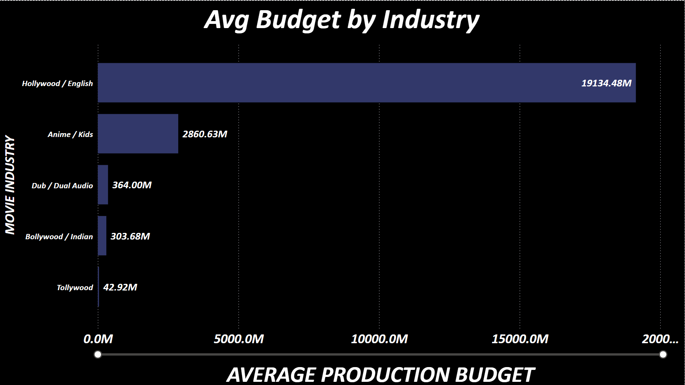

Insights:
- Hollywood dominates budget allocation
- Anime/Kids industry holds second place
- Indian/Bollywood remains comparatively low budget

5.6 Budget vs Downloads Scatterplot

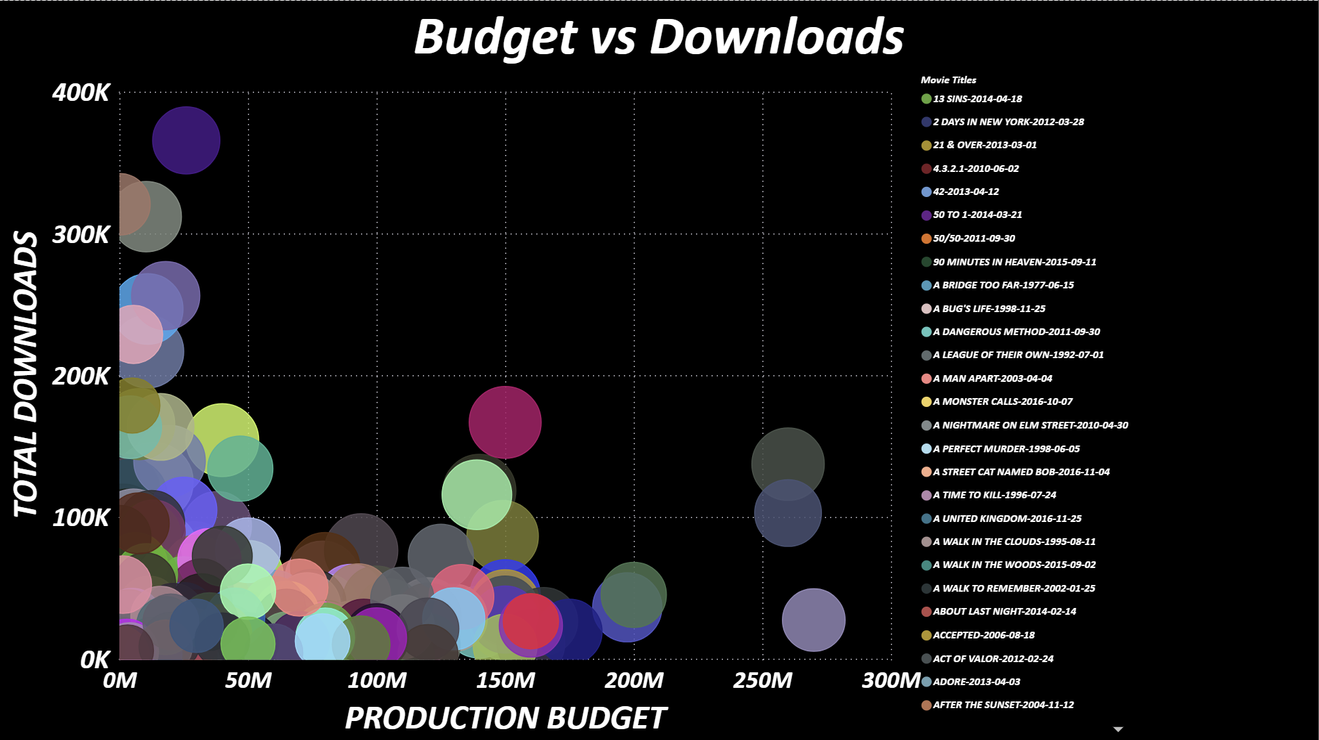
Takeaways:
- High downloads do not require high budgets
- Many low-budget films achieve high piracy due to viral popularity
- Word-of-mouth influence is significant


5.7 Ratings Distribution
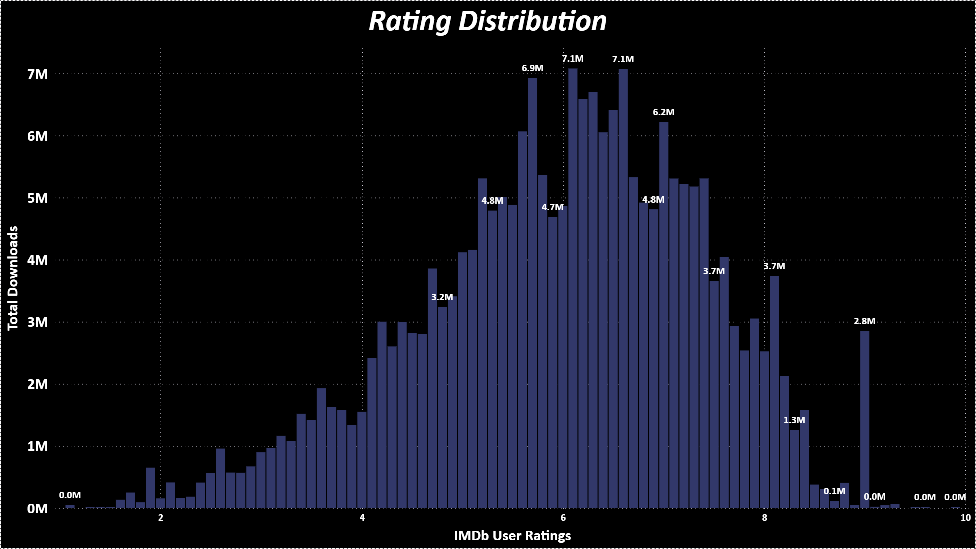
Insights:
- Downloads peak around IMDb rating 6–7
- Extremely low or high-rated films attract less piracy


5.8 Story Length vs Downloads
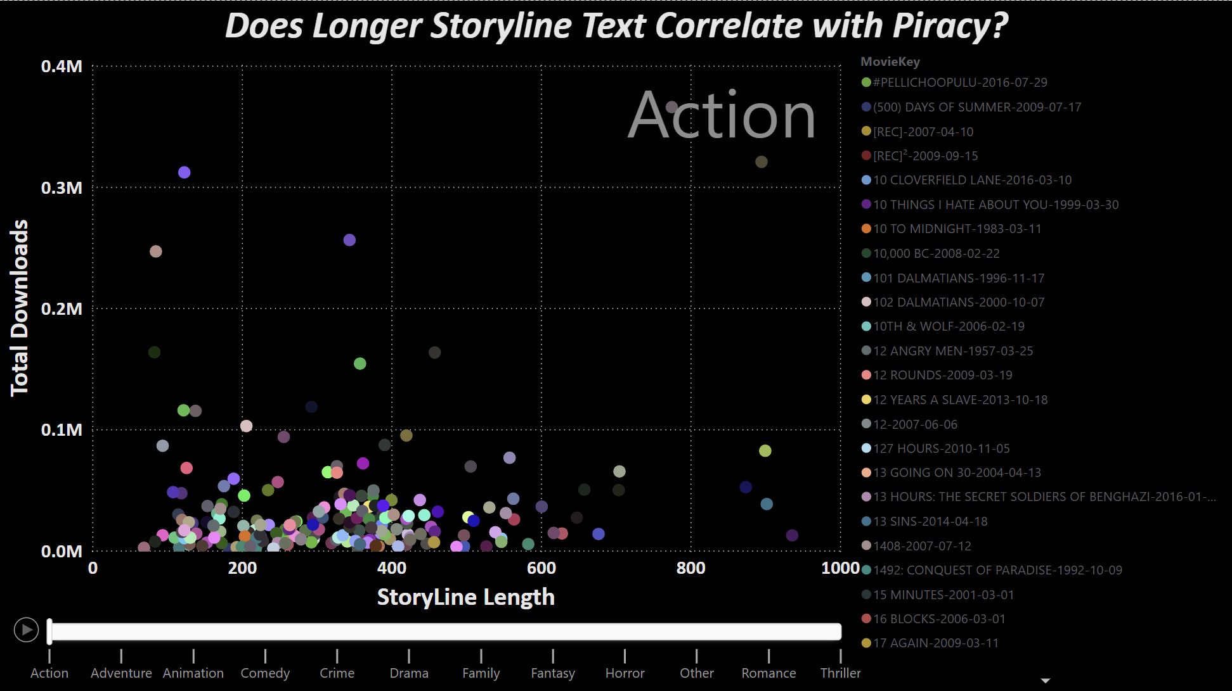
Interpretation:
- Films with shorter storylines draw more piracy
- Suggests audience preference for simpler, high-concept narratives


6. RESULTS & FINDINGS
Key Insights from the Entire Analysis
- Piracy correlates strongly with global popularity.
- NLP keywords show clear drivers of illegal downloads.
  - Action keywords dominate
  - Emotional triggers contribute significantly
- Budget does NOT guarantee engagement.
- Genres differ drastically in budget vs impact.
- Story length plays a subtle role in popularity.
- Industry-level differences impact performance expectations.


7. MANAGERIAL INTERPRETATION
For Movie Studios
- Invest in high-concept, shorter storyline films
- Use NLP-based themes to optimize marketing
- Monitor piracy as an early audience interest signal
For Streaming Platforms
- Acquire films with theme clusters that show strong piracy traction
- Use NLP profiles for personalized recommendations
For Marketers
- Promote emotional & action-driven narratives
- Create targeted campaigns based on keyword similarity


8. LIMITATIONS
- Downloads dataset may not capture all piracy channels
- Keyword extraction is dependent on metadata quality
- Many-to-many relationships increase complexity
- Some industries underrepresented


9. CONCLUSION
This study demonstrates that the combination of:
- NLP,
- Piracy analytics,
- Financial insights, and
- Visual analytics tools like Power BI
provides a deep understanding of what drives movie success.
Our findings support a data-driven framework for predicting audience demand, evaluating story-level appeal, understanding genre economics, and improving studio strategies.


10. REFERENCES
Datasets & APIs
The Movie Database (TMDb). (2024). TMDb API. https://developer.themoviedb.org/
Kaggle. (2023). Movies Dataset (45,000+ movies). https://www.kaggle.com/
Tools & Documentation
Microsoft. (2024). Power BI Documentation. https://learn.microsoft.com/power-bi/
Microsoft. (2024). Power Query M Language Reference. https://learn.microsoft.com/powerquery-m/
Academic Sources on Piracy
Danaher, B., Smith, M. D., Telang, R., & Chen, S. (2014). The effect of piracy website blocking on consumer behavior. Journal of Industrial Economics, 62(3), 1–23.
Cha, H., & Chan-Olmsted, S. (2020). Understanding online content piracy: Motivations and anti-piracy strategies. Journal of Media Economics, 33(2), 65–81.
Bounie, D., Bourreau, M., & Waelbroeck, P. (2006). Piracy and the demand for films: Analysis of a natural experiment. Review of Economic Studies, 73(2), 1–14.
NLP, Storyline, and Movie Analytics Literature
Kao, A., & Poteet, S. R. (2007). Natural language processing and text mining. Springer.
Mikolov, T., Chen, K., Corrado, G., & Dean, J. (2013). Efficient estimation of word representations in vector space. arXiv:1301.3781.
Liu, B. (2020). Sentiment analysis and opinion mining. Morgan & Claypool.

Business Analytics & Visualization
Provost, F., & Fawcett, T. (2013). Data science for business: What you need to know about data mining and data-analytic thinking. O’Reilly Media.
Shmueli, G., Bruce, P. C., Gedeck, P., & Patel, N. R. (2021). Data mining for business analytics: Concepts, techniques, and applications. Wiley.
11. APPENDIX — DASHBOARD PLACEHOLDERS
